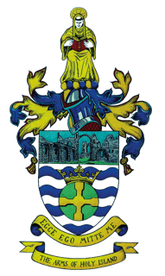

HOLY ISLAND PARISH COUNCIL

Windsor Cottage, 3 Lewin’s Lane, Holy Island, Berwick-upon-Tweed, Northumberland TD15 2SB

Clerk: John A Bevan Tel: (01289) 389359 Email: holyipc@btinternet.com

PARISH COUNCIL ELECTION RESULT

The result of the Election of Parish Councillors held on May 6th 2021 is as follows:

Jonny Gray 75 votes Elected

Kirsty Johnson 71 votes Elected

Gillian Douglas 53 votes Elected

Robert Coombes 50 votes Elected

Maureen Porter 45 votes Elected

Kath Anderson 40 votes

Jutta Hahn 30 votes

Emma Rothera 14 votes.

On behalf of Holy Island Parish Council.

John Bevan. Clerk

May 10th 2021

